How to Load & Develop a Roll of Film
TO DEVELOP FILM, YOU NEED 30 MINUTES. DO NOT BEGIN DEVELOPING IF THERE IS LESS THAN 25 MINUTES REMAINING IN THE CLASS BLOCK.
Gather Supplies:
- 1-2 rolls of exposed T-MAX film
- Developing tank
- Can opener
- Scissors
- Changing bag
- Containers (for mixed chemicals)
- Negative carrier
- 3 Containers for mixing chemicals
- Beaker or measuring cup
- Thermometer
Chemicals:
- Film Developer
- Stop Bath
- Fixer
- Hypo Clearing Agent (HCA)
- Photo Flo
Loading the Film in the Development Tank
- In a changing bag, gather together your exposed film canister(s), can opener, scissors, development tank and film reels. Make sure all of these items are in the bag before you proceed to the next step.

- In a closed changing bag, open the film canister by removing the flat end of the canister. If you have a reusable film canister, DO NOT open with can opener, unscrew the flat end of the canister.
2. 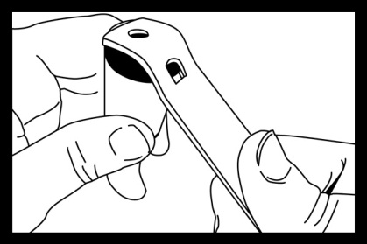 3.
- Take the film out of the canister. Touching the emulsion side of the film will affect the chemicals in the developing process, so try to remove the film without making any contact with the film itself. Push the plastic knob that sticks out of the canister; pull the film out of the canister. The film will unravel but try not to touch the emulsion side.
4. 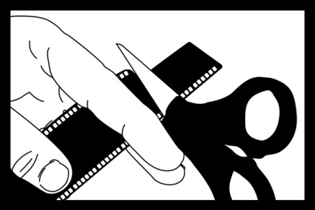 5. 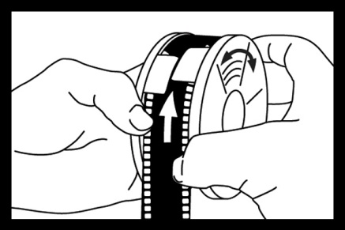
- Cut the end off of the film. Without touching the emulsion side of the film, use your thumb and forefinger to grip the film by the edges and feel toward the end of the film. The end of your film has no exposures on it, so it is safe to touch. Using your fingers as a guide, find your scissors and cut the leader off your film.

- Once the film has an even end, it can be loaded on the reel. Take a reel and feed the first piece of film onto it. It may resist at first but once it passes the ball bearing it seems to pop onto the track. (Remember not to touch the emulsion in areas where the film was exposed).
Most plastic reels have a self-feeding oscillating mechanism that allows the user to feed the film without touching the film. Rotate one side of the reel about 1/8th of a turn and return it to its original position, as this action is repeated the film will wind around the track without any significant problems.
6.
- Toward the end of the reel, you will feel the plastic spindle that was used to pull the film out of the canister. It will find its way into your palms as you wind up your film. Take the scissors and cut this plastic spindle free and continue to load the rest of your film.
Do not pull the tape off the film, as it can cause a small amount of static that can fog your negatives. Once all your film is loaded onto reels place the reels inside your light safe tank and close it up. Be sure that it is secured and all reels are safely inside.
At this point it is safe to open the changing bag. Clean up the canister, lids spindle and discarded film leader. Make sure to save reusable film canisters.
TO DEVELOP FILM, YOU NEED 30 MINUTES. DO NOT BEGIN DEVELOPING IF THERE IS LESS THAN 25 MINUTES REMAINING IN THE CLASS BLOCK.

Developing the film
Follow the posted charts for development times/temperature per film ISO
- Mix Developer – For 1 reel, 1 part developer to 9 parts water to equal 10 oz. For 2 reels, 2 parts developer to 18 parts water to equal 20 oz.
- Developing – Pour developer into tank and start timer immediately. Agitate for 1st 60 seconds and then for 10 seconds every minute for the rest of the development time. Tap tank at the end of each agitation. Once time has expired, dump developer down the drain.
- Stop – 1 minute with constant agitation. Once time has expired, do not dump down drain, save stop.
- Fix – Agitate for the 1st 60 seconds and then for 10 seconds every minute for 8 minutes. Once time has expired, do not dump down drain, save fix. After 8 minutes, open the development tank and look at the film. If the film looks purple or pink, fix for 2 additional minutes with constant agitation. Save fix.
- Final Wash – Fill and dump tank 5 times, and then submerge film in running water for 20 minutes.
- Hang to Dry – With wet fingers, squeegee film from end to end and hand in the closet.
Do not cut and sleeve negatives until they are completely dry and not tacky.

